**1 INTRODUCTION**

Permanent magnet (PM) synchronous motors are widely used in low and mid power applications such as computer peripheral equipments, robotics, adjustable speed drives and electric vehicles. The growth in the market of PM motor drives has demanded the need of simulation tools capable of handling motor drive simulations. Simulations have helped the process of developing new systems including motor drives, by reducing cost and time. Simulation tools have the capabilities of performing dynamic simulations of motor drives in a visual environment so as to facilitate the development of new systems.

In this work, the simulation of a field oriented controlled PM motor drive system is developed using Simulink. The simulation circuit will include all realistic components of the drive system. This enables the calculation of currents and voltages in different parts of the inverter and motor under transient and steady conditions. The losses in different parts can be calculated facilitating the design of the inverter.

A closed loop control system with a PI controller in the speed loop has been designed to operate in constant torque and flux weakening regions. Implementation has been done in Simulink. A comparative study of hysteresis and PWM control schemes associated with current controllers has been made in terms of harmonic spectrum and total harmonic distortion. Simulation results are given for two speeds of operation, one below rated and another above rated speed.

**1.1 Motivation**

Modeling and simulation is usually used in designing PM drives compared to building system prototypes because of the cost. Having selected all components, the simulation process can start to calculate steady state and dynamic performance and losses that would have been obtained if the drive were actually constructed. This practice reduces time, cost of building prototypes and ensures that requirements are achieved.

In works available until now ideal components have been assumed in the inverter feeding the motor and simulations have been carried out. The voltages and currents in different parts of the inverter have not been obtained and hence the losses and efficiency can not be calculated. In this work, the simulation of a PM motor drive system is developed using Simulink. The simulation circuit includes all realistic components of the drive system. This enables the calculation of currents and voltages in different parts of the inverter and motor under transient and steady conditions. The losses in different parts are calculated. A comparative study associated with hysteresis and PWM control techniques in current controllers has been made.

A speed controller has also been designed for closed loop operation of the drive. Design method for the PI controller is also given.

**2 DESCRIPTION OF THE DRIVE SYSTEM**

This chapter deals with the description of the different components such as permanent magnet motors, position sensors, inverters and current controllers of the drive system. A review of permanent magnet materials and classification of permanent magnet motors are also given.

**2.1 Permanent Magnet Synchronous Motor Drive System**

The motor drive consists of four main components, the PM motor, inverter, and control unit and the position sensor. The components are connected as shown in figure 2.1.

Descriptions of the different components are as follows:

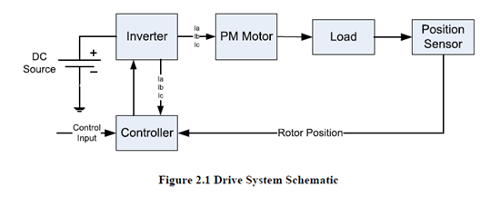

**2.2 Permanent Magnet Synchronous Motor**

A permanent magnet synchronous motor (PMSM) is a motor that uses permanent

Magnets to produce the air gap magnetic field rather than using electromagnets. These motors have significant advantages, attracting the interest of researchers and industry for use in many applications

***2.2.1 Permanent Magnet Materials***

The properties of the permanent magnet material will affect directly the performance of the motor and proper knowledge is required for the selection of the materials and for understanding PM motors. The earliest manufactured magnet materials were hardened steel. Magnets made from steel were easily magnetized. However, they could hold very low energy and it was easy to demagnetize. In recent years other magnet materials such as Aluminum Nickel and Cobalt alloys (ALNICO), Strontium Ferrite or Barium Ferrite (Ferrite), Samarium Cobalt (First

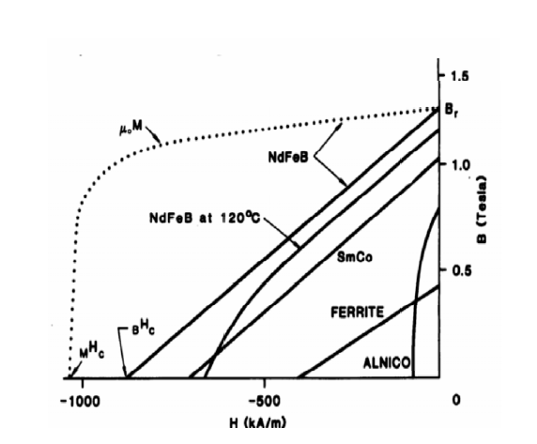Generation rare earth magnet) (SmCo) and Neodymium Iron-Boron (Second generation rare earth magnet) (NdFeB) have been developed and used for making permanent magnets. The rare earth magnets are categorized into two classes: Samarium Cobalt (SmCo) magnets and Neodymium Iron Boride (NdFeB) magnets. SmCo magnets have higher flux density levels but they are very expensive. NdFeB magnets are the most common rare earth magnets used in motors these days. A flux density versus magnetizing field for these magnets is illustrated in figure

**2.2.2 Classification of Permanent Magnet Motors**

**2.2.2.1 Direction of field flux**

PM motors are broadly classified by the direction of the field flux. The first field flux classification is radial field motor meaning that the flux is along the radius of the motor. The second is axial field motor meaning that the flux is perpendicular to the radius of the motor. Radial field flux is most commonly used in motors and axial field flux have become a topic of interest for study and used in a few applications.

2.2.2.2 Flux density distribution

PM motors are classified on the basis of the flux density distribution and the shape of current excitation. They are PMSM and PM brushless motors (BLDC). The PMSM has a sinusoidal-shaped back EMF and is designed to develop sinusoidal back EMF waveforms.

They have the following:

1. Sinusoidal distribution of magnet flux in the air gap

2. Sinusoidal current waveforms

3. Sinusoidal distribution of stator conductors.

BLDC has a trapezoidal-shaped back EMF and is designed to develop trapezoidal back EMF waveforms. They have the following:

1. Rectangular distribution of magnet flux in the air gap

2. Rectangular current waveform

3. Concentrated stator windings.

**2.2.2.3 Permanent magnet radial field motors**

In PM motors, the magnets can be placed in two different ways on the rotor.Depending on the placement they eare called either as surface permanent magnet motor or interior permanent magnet motor. Surface mounted PM motors have a surface mounted permanent magnet rotor. Each of the PM is mounted on the surface of the rotor, making it easy to build, and specially skewed poles are easily magnetized on this surface mounted type to minimize cogging torque. This configuration is used for low speed applications because of the limitation that the magnets will fly apart during high-speed operations. These motors are considered to have small saliency, thus having practically equal inductances in both axes .The permeability of the permanent magnet is almost that of the air, thus the magnetic material becoming an extension of the air gap. For a surface permanent magnet motor. The rotor has an iron core that may be solid or may be made of punched laminations for simplicity in manufacturing. Thin permanent magnets are mounted on the surface of this core using adhesives. Alternating magnets of the opposite magnetization direction produce radially directed flux density across the air gap. This flux density then reacts with currents in windings placed in slots on the inner surface of the stator to produce torque.

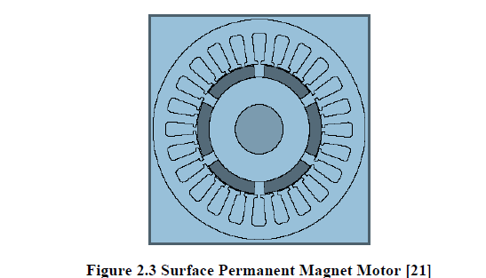

Interior PM motors have interior mounted permanent magnet rotor as shown in figure 2.4. Each permanent magnet is mounted inside the rotor. It is not as common as the surface mounted type but it is a good candidate for high-speed operation. There is inductance variation for this type of rotor because the permanent magnet part is equivalent to air in the magnetic circuit calculation. These motors are considered to have saliency with q axis inductance greater than the d axis inductance ( *Lq* > *Ld* ).

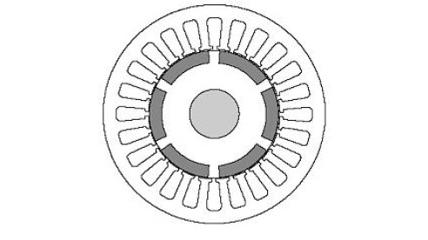

**Figure 2.4 Interior Permanent Magnet Motor**

**2.3 Position Sensor**

Operation of permanent magnet synchronous motors requires position sensors in the rotor shaft when operated without damper winding. The need of knowing the rotor position requires the development of devices for position measurement. There are four main devices for the measurement of position, the potentiometer, linear variable differential transformer, optical encoder and resolvers. The ones most commonly used for motors are encoders and revolvers. Depending on the application and performance desired by the motor a position sensor with the required accuracy can be selected

***2.3.1 Optical Encoders***

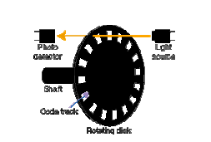 The most popular type of encoder is the optical encoder as shown in figure 2.5, which consists of a rotating disk, a light source, and a photo detector (light sensor). The disk, is mounted on the rotating shaft, has coded patterns of opaque and transparent sectors. As the disk rotates, these patterns interrupt the light emitted onto the photo detector, generating a digital pulse or output signal.

**Figure 2.5 Optical Encoder**

Optical encoders offer the advantages of digital interface. There are two types of optical encoders, incremental encoder and absolute encoder.

**2.3.1.1 Incremental encoders**

Incremental encoders have good precision and are simple to implement but they suffer from lack of information when the motor is at rest position and in order for precise position the motor most be stop at the starting point. The most common type of incremental encoder uses two output channels (A and B) to sense position. Using two code tracks with sectors positioned 90° degrees out of phase, the two output channels of the quadrature encoder indicate both position and direction of rotation as shown in figure 2.6. If A leads B, for example, the disk is rotating in a clockwise direction. If B leads A, then the disk is rotating in a counter-clockwise direction. By monitoring both, the number of pulses and the relative phase of signals A and B, it's possible to track position and direction of rotation. Some quadrature encoders also include a third output channel,called a zero or index or reference signal, which supplies a single pulse per revolution. This single pulse is used for precise determination of a reference position. The precision of the encoder is fix by its code disk but it can be increased by detecting the Up and Down transitions on both the A and B channels.

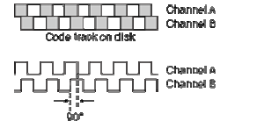

**Figure 2.6 Quadrature Encoder Channels**

**2.3.1.2 Absolute encoders**

The absolute encoder, as shown in figure 2.7 captures the exact position of the rotor with a precision directly related to the number of bits of the encoder. It can rotate indefinitely and even if the motor stops the position can be measured or obtained. It provides a “whole word” output with a unique code pattern representing each position. This code is derived from independent tracks on the encoder disc (one for each “bit” of resolution) corresponding to individual photo detectors. The output from these detectors is HI (light) or LO (dark) depending on the code disc pattern for that particular position output windings. In consequence of the excitement applied on the reference winding Vref and along with the angular movement of the motor shaft θ, the respective voltages are generated by resolver output windings V sin, V cos.

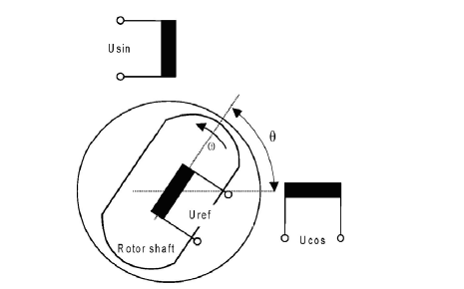

**Figure 2.7 Resolver**

The frequency of the generated voltages is identical to the reference voltage and their amplitudes vary according to the sine and cosine of the shaft angle θ. Considering that one of the output windings is aligned with the reference winding, then it is generated full voltage on that output winding and zero voltage on the other output winding and vice versa. The rotor angle θ can be extracted from these voltages shown in figure 2.8. 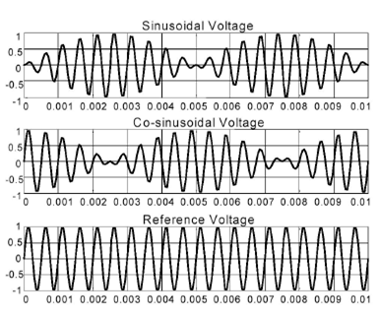

**Figure 2.8 Excitation and Output Signal of the Resolver**

The shaft angle can be determined by an Inverse Tangent [8] function of the quotient of the sampled resolver output voltages V sin, V cos. This determination can be expressed, in terms of resolver output voltages, as follows:

tan (sinθ) = a tan (u sin / u cos)

**2.4 Current Controlled Inverter**

The motor is fed form a voltage source inverter with current control. The control is

Performed by regulating the flow of current through the stator of the motor. Current controllers are used to generate gate signals for the inverter. Proper selection of the inverter devices and selection of the control technique will guarantee the efficacy of the drive.

***2.4.1 Inverter***

Voltage Source Inverters are devices that convert a DC voltage to AC voltage of

Variable frequency and magnitude. They are very commonly used in adjustable speed drives and are characterized by a well defined switched voltage wave form in the terminals. Figure 2.9 shows a voltage source inverter. The AC voltage frequency can be variable or constant depending on the application.

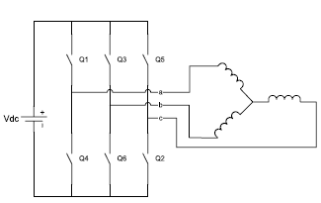

**Figure 2.9 Voltage Source Inverter Connected to a Motor**

Three phase inverters consist of six power switches connected as shown in figure 2.9 to a DC voltage source. The inverter switches must be carefully selected based on the requirements of operation, ratings and the application. There are several devices available today and these are thyristors, bipolar junction transistors (BJTs), MOS field effect transistors (MOSFETs), insulated gate bipolar transistors (IGBTs) and gate turn off thyristors (GTOs). The devices list with their respective power switching capabilities are shown in table 2.1 MOSFETs and IGBTs are preferred by industry because of the MOS gating permits high power gain and control advantages. While MOSFET is considered a universal power device for low power and low voltage applications, IGBT has wide acceptance for motor

drives and other application in the low and medium power range. The power devices when used in motor drives applications require an inductive motor current path provided by anti parallel diodes when the switch is turned off. Inverters with anti parallel diodes are shown in figure 2.10

**Table 2.1 Devices Power and Switching Capabilities**

|  |  |  |
| --- | --- | --- |
| Device | Power Capability | Switching Speed |
| BJT | Medium | Medium |
| GTO | High | Low |
| IGBT | Medium | Medium |
| MOSFET | Low | High |
| THYRISTOR | High | Low |

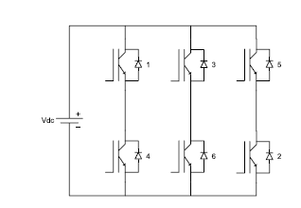

**Figure 2.10 Inverter with IGBTs and Anti parallel Diodes**

**2.4.2 IGBTs**

IGBTs provide high input impedance and are used for high voltage applications. The high input impedance allows the device to switch with a small amount of energy and for high voltage applications the device must have large blocking voltage ratings. The device behavior is described by parameters like voltage drop or on-resistance, turn on time and turn off time. Figure 2.11 shows the characteristic plot of the device.

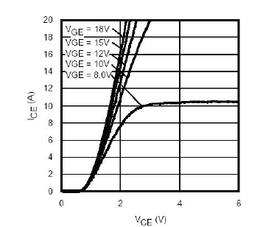

**Figure 2.11 Typical IGBT Output Characteristics**

The symbolic representation and the equivalent circuit of an IGBT are shown in

figure 2.12

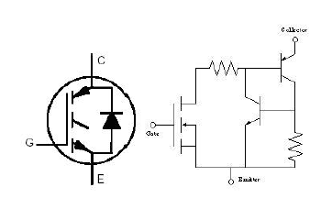

**Figure 2.12 IGBT Symbol and Equivalent Circuit**

**2.4.3 Current Control**

The power converter in a high-performance motor drive used in motion control essentially functions as a power amplifier, reproducing the low power level control signals generated in the field orientation controller at power levels appropriate for the driven machine. High-performance drives utilize control strategies which develop command signals for the AC machine currents. The basic reason for the selection of current as the controlled variable is the same as for the DC machine; the stator dynamics (effects of stator resistance, stator inductance, and induced EMF) are eliminated. Thus, to the extent that the current regulator functions as an ideal current supply, the order of the system under control is reduced and the complexity of the controller can be significantly simplified.

Current regulators for AC drives are complex because an AC current regulator must control both the amplitude and phase of the stator current. The AC drive current regulator forms the inner loop of the overall motion controller. As such, it must have the widest bandwidth in the system and must, by necessity, have zero or nearly zero stead state error. Both current source inverters (CSI) and voltage source inverters (VSI) can be operated in controlled current modes. The current source inverter is a "natural" current supply and can readily be adapted to controlled current operation. The voltage source inverter requires more

complexity in the current regulator but offers much higher bandwidth and elimination of current harmonics as compared to the CSI and is almost exclusively used for motion control applications. Current controllers can be classified into two groups, hysteresis and PWM current controllers. Both types are discussed bellow.

**2.4.3.1 *PWM Current Controller***

PWM current controllers are widely used. The switching frequency is usually keptconstant. They are based in the principle of comparing a triangular carrier wave of desire switching frequency and is compared with error of the controlled signal. The error signal comes from the sum of the reference signal generated in the controller and the negative of the actual motor current. The comparison will result in a voltage control signal that goes to the gates of the voltage source inverter to generate the desire output. Its control will respond according to the error. If the error command is greater than the triangle waveform, the inverter leg is held switched to the positive polarity (upper switch on). When the error command is less than the triangle waveform, the inverter leg is switched to the negative polarity (lower switch on). This will generate a PWM signal like in figure 2.13. The inverter leg is forced to switch at the frequency of the triangle wave and produces an output voltage proportional to the current error command. The nature of the controlled output current consists of a reproduction of the reference current with high-frequency PWM ripple super imposed. 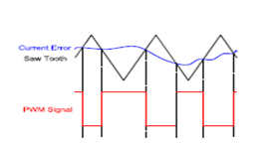

**Fig 2.13 pwm controller**

**2.4.3.2 Hysteresis current controller**

Hysteresis current controller can also be implemented to control the inverter currents. The controller will generate the reference currents with the inverter within a range which is fixed by the width of the band gap. In this controller the desired current of a given phase is summed with the negative of the measured current. The error is fed to a comparator having a hysteresis band. When the error crosses the lower limit of the hysteresis band, the upper switch of the inverter leg is turned on. But when the current attempts to become less than the upper reference band, the bottom switch is turned on. Figure 2.15 shows the hysteresis band with the actual current and the resulting gate signals. This controller does not have a specific switching frequency and changes but it related with band width.. 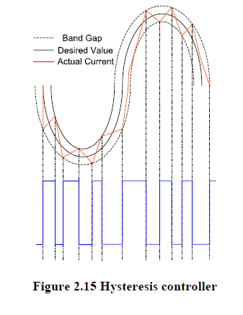

**3 MODELING OF PM DRIVE SYSTEM**

This chapter deals with the detailed modeling of a permanent magnet synchronous motor. Field oriented control of the motor in constant torque and flux-weakening regions are discussed. Closed loop control of the motor is developed using a PI controller in the speed loop. Design of the speed controller is discussed.

**3.1 Detailed Modeling of PMSM**

Detailed modeling of PM motor drive system is required for proper simulation of the system. The d-q model has been developed on rotor reference frame as shown in figure 3.1. At any time t, the rotating rotor d-axis makes and angle θr with the fixed stator phase axis and rotating stator MMF makes an angle α with the rotor d-axis.

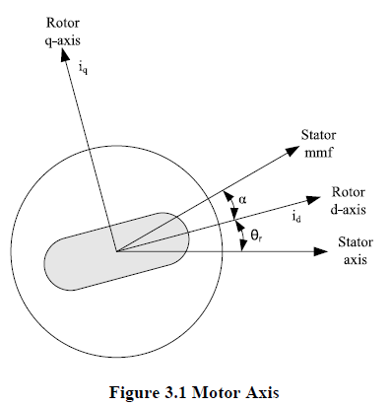

The model of PMSM without damper winding has been developed on rotor reference frame using the following assumptions:

1) Saturation is neglected.

2) The induced EMF is sinusoidal.

3) Eddy currents and hysteresis losses are negligible.

4) There are no field current dynamics.

Voltage equations are given by:

Vq = Rsiq +ωrλd + ρλq**3.1**

*Vd* = Rsid−ωrλq + ρλd **3.2**

Flux Linkages are given by

λq = Lqiq**3.3**

λq = Ldid+λf **3.4**

Substituting equations 3.3 and 3.4 into 3.1 and 3.2

Vq = Rsiq +ωrλd(Ld id +λf) + ρLqiq **3.5**

*Vd* = Rsid−ωrLqiq + ρ (Ldid +λf) **3.6**

Arranging equations 3.5 and 3.6 in matrix form

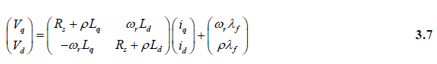

The developed torque motor is being given by

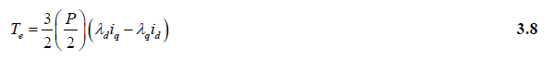

The mechanical Torque equation is

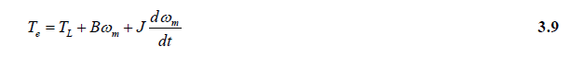

Solving for the rotor mechanical speed form equation 3.9

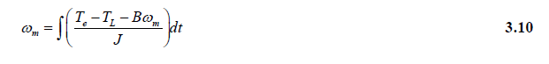

and



In the above equations ωr is the rotor electrical speed where as ωm is the rotor mechanical speed.

***3.1.1 Parks Transformation and Dynamic d q Modeling***

The dynamic d q modeling is used for the study of motor during transient and steady state. It is done by converting the three phase voltages an currents to dqo variables by using Parks transformation Converting the phase voltages variables v abc to v dqo variables in rotor reference frame the following equations are obtained

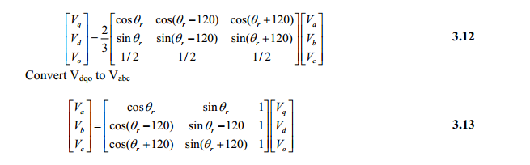

***3.1.2 Equivalent Circuit of Permanent Magnet Synchronous Motor***

Equivalent circuits of the motors are used for study and simulation of motors.

From the d-q modeling of the motor using the stator voltage equations the equivalent circuit of the motor can be derived. Assuming rotor d axis flux from the permanent magnets is represented by a constant current source as described in the following equation λ *f* = *Ldm *if* , figure 3.2 is obtained.

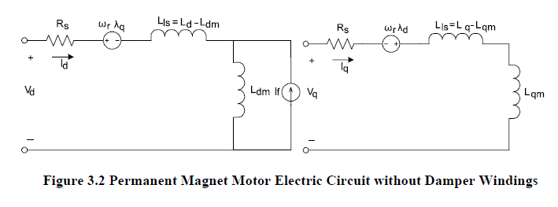

**3.2 PM Motor Control**

Control of PM motors is performed using field oriented control for the operation of

Synchronous motor as a dc motor. The stator windings of the motor are fed by an inverter that generates a variable frequency variable voltage. Instead of controlling the inverter frequency independently, the frequency and phase of the output wave are controlled using a position sensor as shown in figure 3.3.



**Figure 3.3 Self Control Synchronous Motor**

Field oriented control was invented in the beginning of 1970s and it demonstrates that an induction motor or synchronous motor could be controlled like a separately excited dc motor by the orientation of the stator mmf or current vector in relation to the rotor flux to achieve a desired objective. In order for the motor to behave like DC motor, the control needs knowledge of the position of the instantaneous rotor flux or rotor position of permanent magnet motor. This needs a resolver or an absolute optical encoder. Knowing the position, the three phase currents can be calculated. Its calculation using the current matrix depends on the control desired. Some control options are constant torque and flux weakening. These options are based in the physical limitation of the motor and the inverter. The limit is established by the rated speed of the motor, at which speed the constant torque operation finishes and the flux weakening starts as shown in figure 3.4.

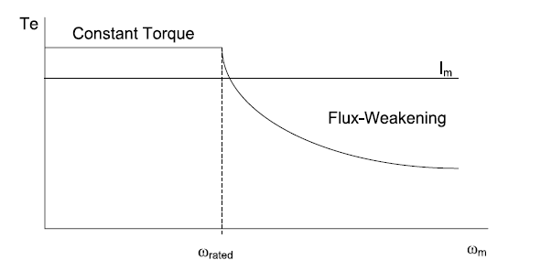

**Figure 3.4 Steady State Torque versus Speed**

**3.2.1 Field Oriented Control of PM Motors**

The PMSM control is equivalent to that of the dc motor by a decoupling control

Known as field oriented control or vector control. The vector control separates the torque component of current and flux channels in the motor through its stator excitation. The vector control of the PM synchronous motor is derived from its dynamic model Considering the currents as inputs, the three currents are:

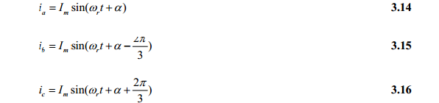

Writing equations 3.14 to 3.16 in the matrix form:

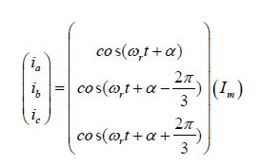

Where α is the angle between the rotor field and stator current phasor, ωr is the electrical rotor speed. The previous currents obtained are the stator currents that must be transformed to the rotor reference frame with the rotor speed ωr, using Park’s transformation. The q and d axis currents are constants in the rotor reference frames since α is a constant for a given load torque. As these constants, they are similar to the armature and field currents in the separately excited dc machine. The q axis current is distinctly equivalent to the armature current of the dc machine; the d axis current is field current, but not in its entirety. It is only a partial field current; the other part is contributed by the equivalent current source representing the permanent magnet field. For this reason the q axis current is called the torque producing component of the stator current and the d axis current is called the flux producing component of the stator current. Substituting equation 3.17 and 3.12 is obtain id and iq in terms of Im as follows

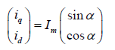

Using equations 3.1, 3.2, 3.8 and 3.18 the electromagnetic torque equation is obtained as given below.

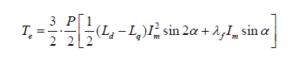

**3.2.1.1 *Constant torque operation***

Constant torque control strategy is derived from field oriented control, where the

Maximum possible torque is desired at all times like the dc motor. This is performed by making the torque producing current iq equal to the supply current Im. That results in selecting the α angle to be 90 º degrees according to equation3.18. By making the id current equal to zero the torque equation can be rewritten 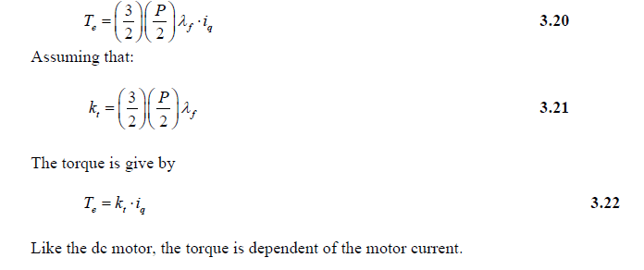

**3.2.1.2 *Flux-weakening***

Flux weakening is the process of reducing the flux in the d axis direction of the motor which results in an increased speed range. The motor drive is operated with rated flux linkages up to a speed where the ratio between the induced emf and stator frequency (V/f) is maintained constant. After the base frequency, the V/f ratio is reduced due to the limit of the inverter dc voltage source which is fixed. The weakening of the field flux is required for operation above the base frequency.

This reduces the V/f ratio. This operation results in a reduction of the torque proportional to a change in the frequency and the motor operates in the constant power region[22].The rotor flux of PMSM is generated by permanent magnet which can not be directly reduced as induction motor. The principle of flux-weakening control of PMSM is to increase negative direct axis current and use armature reaction to reduce air gap flux, which equivalently reduces flux and achieves the purpose of flux-weakening control[28].This method changes torque by altering the angle between the stator MMF and the rotor d axis. In the flux weakening region where ωr > ωrated angle α is controlled by proper control of id and iq for the same value of stator current. Since iq is reduced the output torque is

also reduced. The angle α can be obtained as:

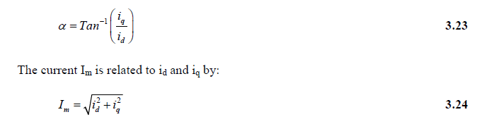

**Flux-weakening control realization**

The realization process of equivalent flux-weakening control is as follows,

1) Measuring rotor position and speed ωr from a sensor which is set in motor rotation axis.

2) The motor at the flux weakening region with a speed loop, Te* is obtained from the PI controller.



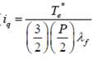

4) Calculate Id* using equation

**

5) Calculate α using equation 3.23.

6) Using α and rotor position the controller will generate the reference currents as per equation 3.17.

7) Then the current controller makes uses of the reference signals to control the inverter for the desired output currents.

8) The load torque is adjust to the maximum available torque for the reference speed



**3.3 Speed Control of PM Motor**

Many applications, such as robotics and factory automation, require precise control of speed and position. Speed Control Systems allow one to easily set and adjust the speed of a motor. The control system consists of a speed feedback system, a motor, an inverter, a controller and a speed setting device. A properly designed feedback controller makes the system insensible to disturbance and changes of the parameters. The purpose of a motor speed controller is to take a signal representing the demanded speed, and to drive a motor at that speed. Closed Loop speed control systems have fast response, but become expensive due to the need of feed back components such as speed sensors.

***3.3.1 Implementation* of the Speed Control Loop**

For a PM motor drive system with a full speed range the system will consist of a motor, an inverter, a controller (constant torque and flux weakening operation, generation of reference currents and PI controller ) as shown in figure 3.5.

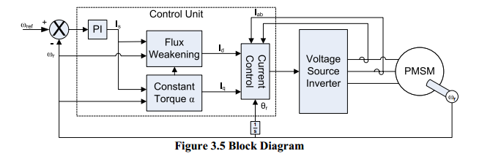

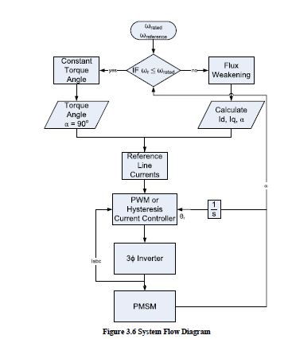

The operation of the controller must be according to the speed range. For operation

up to rated speed it will operate in constant torque region and for speeds above rated speed it will operate in flux-weakening region. In this region the d-axis flux and the developed torque are reduced. The process can be easily understood with the flow diagram in figure 3.6. proportional to the input error and an integration to make the steady state error zero for a step change in the input. Block diagram of the PI controller is shown in figure 3.7.

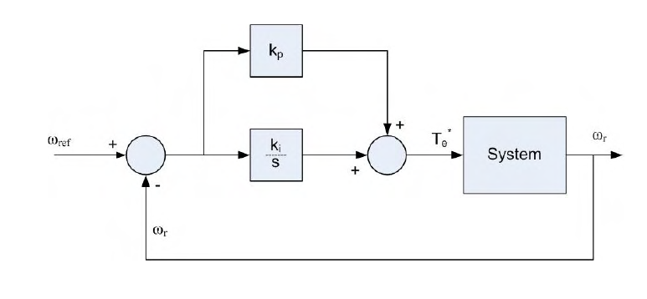

**Figure 3.7 PI Controller**

Speed control of motors mainly consist of two loops the inner loop for current and the outer loop for speed. The order of the loops is due to their response, how fast they can be changed. This requires a current loop at least 10 times faster than the speed loop. Since the PMSM is operated using field oriented control, it can be modeled like a dc motor. The design begins with the innermost current loop by drawing the block diagram. But in PMSM drive system the motor has current controllers which make the current loop. The current control is performed by the comparison of the reference currents with the actual motor currents. The design of the speed loop assumes that the current loop is at least 10 times faster than speed loop, allowing to reduce the system block diagram by considering the current loop

to be of unity gain as shown in figure 3.8.

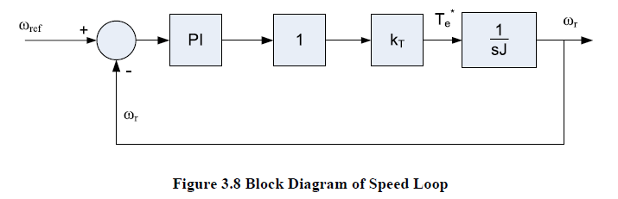

The open loop transfer function of the motor is given by:

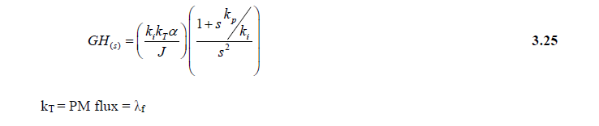

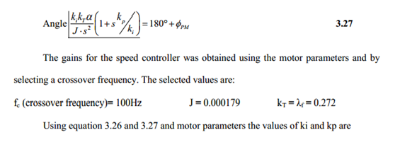The crossover frequency has been selected an order smaller than the current loop. To satisfy dynamic response without oscillations the phase margin ( *PM* φ ) should be greater th45º, preferably close to 60º. Knowing the motor parameters and phase margin, the ki and kp gains can be obtained for the motor controller using equations 3.26 and 3.27. 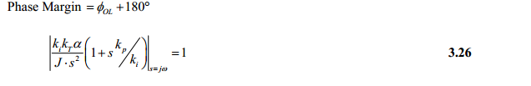

**4 DRIVE SYSTEM SIMULATIONS IN SIMULINK**

This chapter describes different tools available for electrical and electronic systems Simulation and then justification is given for selecting Simulink for the PMSM system Block by block an explanation is given for Simulink simulation of the drive system.

**4.1 Simulation Tools**

Study of electric motor drives needs the proper selection of a simulation tool. Their Complex models need computing tools capable of performing dynamic simulations. Today with the growth in computational power there is a wide selection of software titles available for electrical simulations such as ACSL, ESL, EASY5, and PSCSP are for general systems and SPICE2, EMTP, and ATOSEC5 for simulating electrical and electronic circuits. IESE and SABER are examples of general-purpose electrical network simulation programs that have provisions for handling user-defined modules. SIMULINK® is a toolbox extension of the MATLAB program. It is a program for simulating dynamic systems .Simulink has the advantages of being capable of complex dynamic system simulations, graphical environment with visual real time programming and broad selection of Tool boxes. The simulation environment of Simulink has a high flexibility and Expandability which allows the possibility of development of a set of functions for a detailed analysis of the electrical drive. Its graphical interface allows selection of functional blocks, their placement on a worksheet, selection of their functional parameters interactively, and description of signal flow by connecting their data lines using a mouse device. System blocks are constructed of lower level blocks grouped into a single mask able block. Simulink simulates analogue systems and discrete digital systems.

**4.2 Simulink Simulation of PMSM Drive**

The PM motor drive simulation was built in several steps like abc phase transformation to dqo variables, calculation torque and speed, and control circuit.

The abc phase transformation to dqo variables is built using Parks transformation and for the dqo to abc the reverse transformation is used. For simulation purpose the voltages are the inputs and the current are output. Parks transformation used for converting Vabc to Vdqo is shown in figure 4.1 and the reverse transformation for converting Idqo to Iabc is shown in figure 4.2.

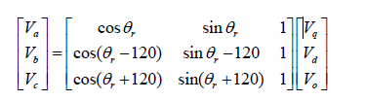

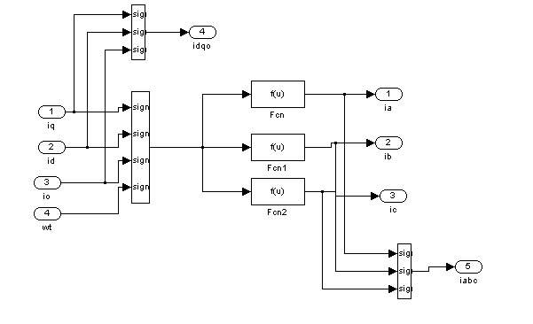

fig 4.1

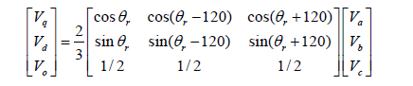



Fig 4.2

The d and q axis motor circuits built using Simulink elements are shown in figure 4.1 and 4.2

Figure 4.3 shows the torque block in Simulink. This block is developed using

equation 3.8 for torque developed.

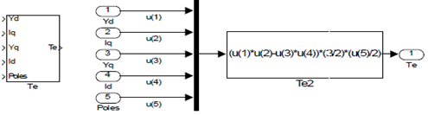

**fig 4.3 Torque Block**

The speed of the motor is obtained using figure 4.3 and equation 3.9. The developed speed block is shown in figure 4.4

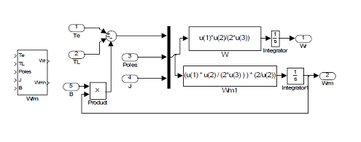

**Fig 4.4 Speed Block**

The vector control requires a block for the calculation of the reference current using the α angle, the position of the rotor and the magnitude of the Im. The block is shown in figure 4.5 It is built using equation 3.17.

The below figure shows the generation of reference currents by using the formulas to compare with the motor currents these are shown in MATLAB/SIMULINK file.



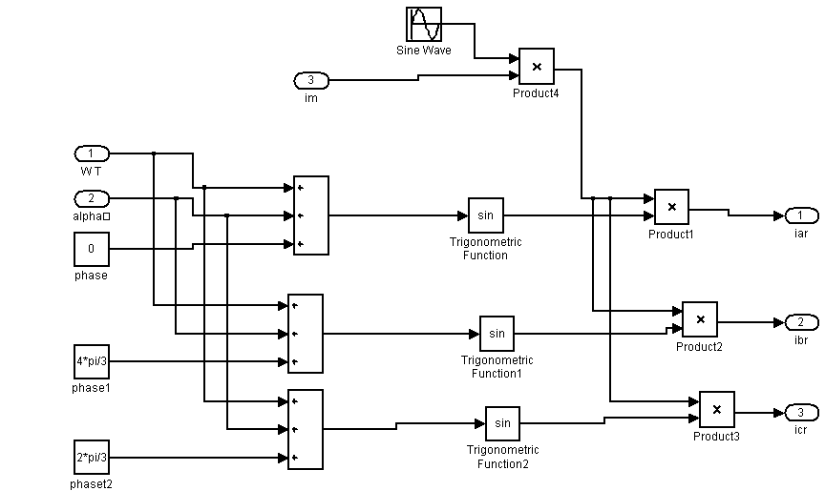

fig 4.5

The inverter is implemented in Simulink as shown in figure 4.6. The inverter consists of the "universal bridge" block from the power systems tool box with the parameters of the IGBT that was presented in chapter 2. The voltages and currents in the motor and in all the devices of the inverter can be obtained. The losses in the inverter and motor can be calculated. In this project we are implemented voltage source inverter for achieving good dynamic response of permanent magnet synchronous motor. the complete mat lab simulink file shown in below figure.

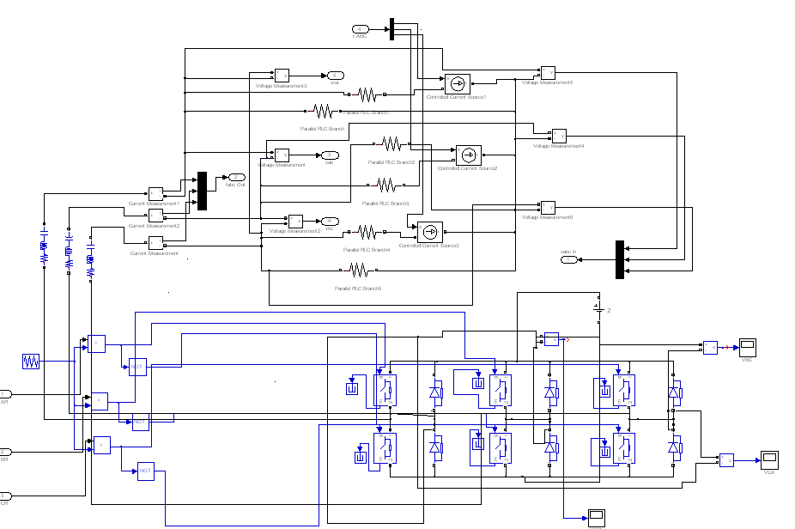

For proper control of the inverter using the reference currents, current controllers are implemented to generate the gate pulses for the IGBT’s. Current controllers used are shown in figure 4.6and 4.7

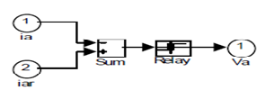

**Fig4.6Hysteresiscurrentcontroller**

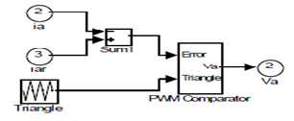

**Fig 4.7 Pwm current controller**

Using all the drive system blocks the complete closed loop Matlab block has been developed as Shown in figure 4.8

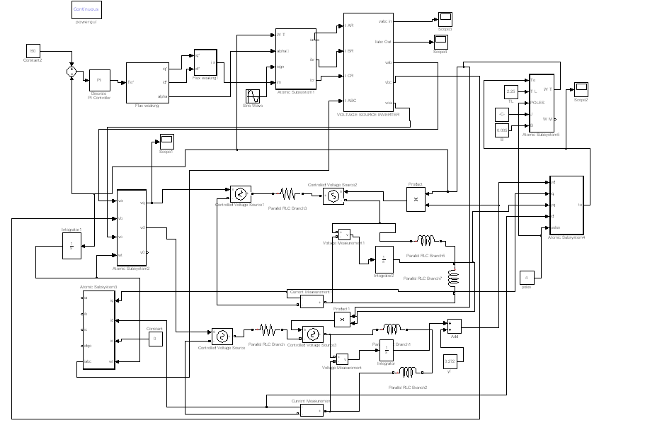

**5 SIMULATION RESULTS**

This chapter deals with the simulation results of PMSM drive system. The parameters of the motor and IGBT parameters are also given. Comparative study of the current controllers used in the system is given in tabular form.

**5.1 Simulation Results**

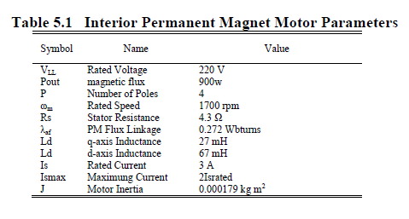 The system built in Simulink for a PMSM drive system has been tested with the two current control methods, Hysteresis and PWM, at the constant torque and flux-weakening regions of operation. The motor parameters used for simulation are given in table 5.1. These parameters were taken from reference. The motor is operated with constant torque up to its rated speed and beyond that rated speed flux-weakening mode is adopted. Simulation results are given at electrical speeds of 143 radians per second and 187 radians per second.

PULSES TO IGBT:

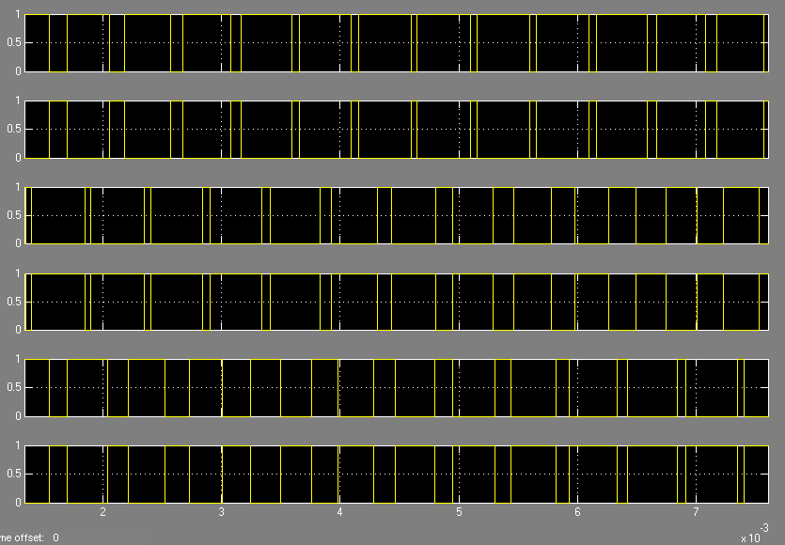

By comparing the reference current and motor current error signal is generated and these error signal is compare with pulse width modulation signal gate pulses are got and these gate pulses are shown above

**VOLTAGE SOURCE INVERTER OUTPUT VOLTAGES:**

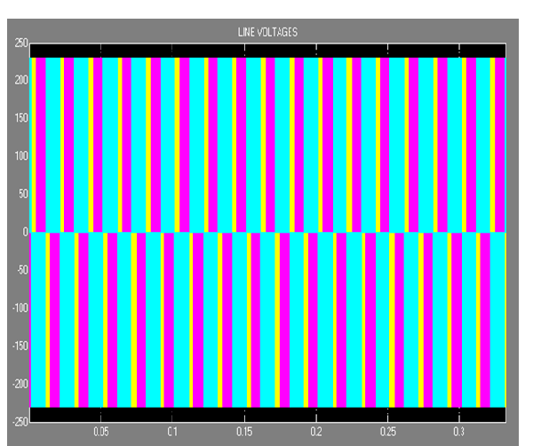

**Gate pulses are given top igbt .based on gate pulses output voltages are generated and these gate pulses are shown above figure**

**REFERENCE CURRENTS GENERATION**

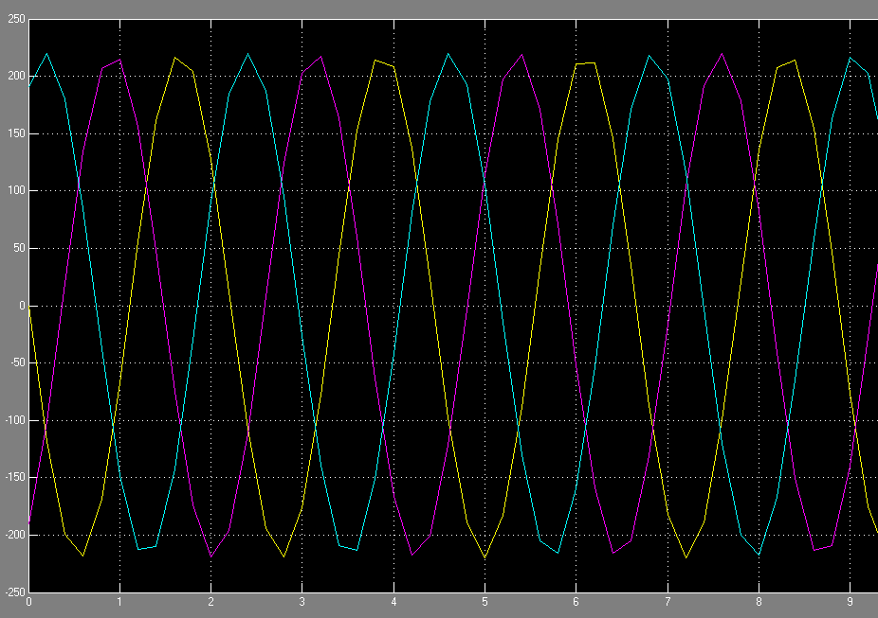

**By using frequency and angle between rotor field and stator current phasor reference currents are generated and reference current are shown in figure**

**PMSM OPERATING BELOW RATED SPEED**

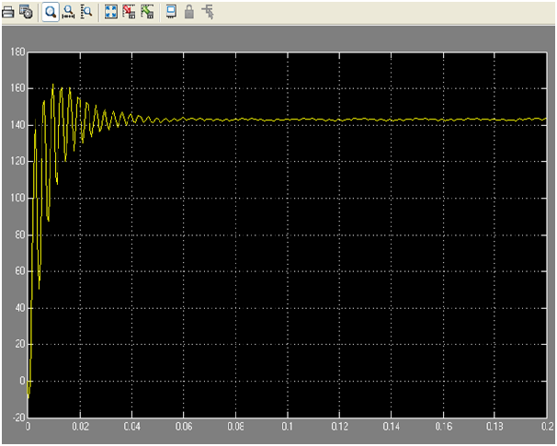

**This is the speed waveform for below rated speed**

**PMSM OPERATING ABOVE RATED SPEED**

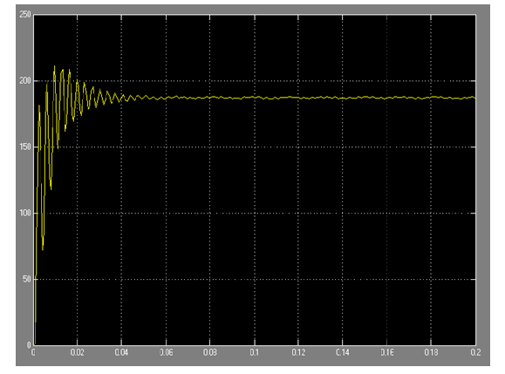

**This is the wave form for above rated speed**

**6 CONCLUSION**

**A speed controller has been designed successfully for closed loop operation of the pmsm drive system so that the motor runs at the commanded speed(or)reference speed. The simulated system has a fast response with practically zero steady state error thus validating the design of speed controller**

**In our project pi controller associated with pwm technique is used.pwm has many advantages like total harmonic distortion zero steady state error**

**constant torque method is used for below rated speed flux weaking is used for above rated speed.**

**REFERENCES**

[1] T. Sebastian, G. Slemon, and M. Rahman, "Modelling of permanent magnet

synchronous motors," *Magnetics, IEEE Transactions on*, vol. 22, pp. 1069-1071,

1986.

[2] T. M. Jahns, G. B.Kliman, and T. W. Neumann, "Interior Permanent-Magnet

Synchronous Motors for Adjustable-Speed Drives," *Industrial Applications, IEEE*

*Transactions on*, vol. IA-22, pp. 738-746, 1986.

[3] P. Pillay and R. Krishnan, "Modeling of permanent magnet motor drives," *Industrial*

*Electronics, IEEE Transactions on*, vol. 35, pp. 537-541, 1988.

[4] P. Pillay and R. Krishnan, "Modeling, simulation, and analysis of permanent-magnet

motor drives. I. The permanent-magnet synchronous motor drive," *Industry*

*Applications, IEEE Transactions on*, vol. 25, pp. 265-273, 1989.

[5] S. Morimoto, Y. Tong, Y. Takeda, and T. Hirasa, "Loss minimization control of

permanent magnet synchronous motor drives," *Industrial Electronics, IEEE*

*Transactions on*, vol. 41, pp. 511-517, 1994.

[6] A. H. Wijenayake and P. B. Schmidt, "Modeling and analysis of permanent magnet

synchronous motor by taking saturation and core loss into account," 1997.

[7] K. Jang-Mok and S. Seung-Ki, "Speed control of interior permanent magnet

synchronous motor drive for the flux weakening operation," *Industry Applications,*

*IEEE Transactions on*, vol. 33, pp. 43-48, 1997.

[8] B. K. Bose, *Modern power electronics and AC drives*: Prentice Hall, 2002.

.